LABORATORY RECORD
Course | Full Stack Web Development | Date | 22-09-2026
Course Code | 23CM4121 | Exp. No. | 4
Student Name | Badana Pranathi | Roll No. | A24126552071

1. TITLE
Drawing Graphics with the HTML5 Canvas API and Designing a Styled Webpage Using Internal CSS (Flexbox, Gradients, Hover Effects)

2. AIM
To draw basic shapes and text on an HTML5 canvas using JavaScript's 2D drawing context, and to design a visually styled webpage - with a header, navigation bar, content cards and footer - using internal CSS features such as gradients, Flexbox layout, box-shadow, and hover effects.

3. OBJECTIVE
The objectives of this experiment are:
- To create a <canvas> element and access its 2D rendering context using getContext('2d').
- To draw a filled rectangle, a filled circle (arc) and a straight line on the canvas with distinct colours.
- To render custom text on the canvas using the font and fillText properties/methods.
- To structure a webpage with a header, navigation bar, content section and footer.
- To style the page using internal CSS: gradients, text-shadow, Flexbox layout, border-radius and box-shadow.
- To apply hover effects on navigation links and buttons using the :hover pseudo-class.

4. THEORY
The HTML5 <canvas> element provides a pixel-based drawing surface controlled entirely through JavaScript. Its 2D rendering context (obtained via getContext('2d')) exposes methods such as fillRect(), arc(), moveTo()/lineTo()/stroke() and fillText() for drawing shapes and text, along with properties like fillStyle, strokeStyle, lineWidth and font to control their appearance. Internal CSS, written within a <style> block in the document, allows a page to be styled without an external stylesheet. Modern CSS layout features such as Flexbox (display: flex) make it straightforward to arrange elements like content cards in a responsive row, while properties such as linear-gradient, box-shadow, border-radius and the :hover pseudo-class add visual polish and interactivity.
Application Flow: Part A - Create Canvas -> Get 2D Context -> Draw Shapes & Text | Part B - Structure Page (header, nav, cards, footer) -> Apply Internal CSS -> Add Hover Interactivity

5. ALGORITHM / PROCEDURE
- Part A: Create an HTML5 document with a centred heading and a <canvas> element of width 500 and height 300, bordered using CSS.
- Access the canvas using document.getElementById() and obtain its 2D drawing context with getContext('2d').
- Draw a filled violet rectangle using fillStyle and fillRect(x, y, width, height).
- Draw a filled green circle by starting a new path, defining an arc() and calling fill().
- Draw a red line by starting a new path, using moveTo() and lineTo() to define its endpoints, and calling stroke() with a defined lineWidth.
- Set the font and fillStyle, then use fillText() to draw the student's name onto the canvas.
- Part B: Create a new HTML document and define internal CSS inside a <style> block for the body, header, nav, cards, buttons and footer.
- Style the body with a linear-gradient background and structure the page with a <header>, a <nav> containing four links, a <div class='container'> holding three '.card' elements, and a <footer>.
- Use Flexbox (display: flex, justify-content: center, gap) on the container to lay the three cards out in a centred row.
- Add hover effects on the navigation links (nav a:hover) and the 'Read More' buttons (button:hover) to change their colour on mouse-over.
- Save and open the file in a browser to verify the canvas drawing and the styled page layout.

6. PROGRAM
index.html
<!DOCTYPE html>
<html>

<head>
<b><h1>PART A</h1></b>
<!-- Title of the webpage -->
<title>My Styled Webpage</title>

<style>
/* Center the heading */
h1 {
text-align: center;
}

/* Center the canvas */
canvas {
display: block;
margin: 20px auto;
border: 2px solid black;
}
</style>

</head>

<body>

<!-- Main Heading -->
<h1>HTML5 Canvas</h1>

<!-- Canvas Element -->
<canvas id="myCanvas" width="500" height="300">
Your browser does not support the canvas element.
</canvas>

<!-- JavaScript for Drawing -->
<script>

// Access the canvas
var canvas = document.getElementById("myCanvas");

// Get 2D drawing context
var ctx = canvas.getContext("2d");

// Draw a Rectangle
ctx.fillStyle = "violet";
ctx.fillRect(20, 20, 150, 80);

// Draw a Circle
ctx.beginPath();
ctx.arc(280, 60, 40, 0, 2 * Math.PI);
ctx.fillStyle = "green";
ctx.fill();

// Draw a Line
ctx.beginPath();
ctx.moveTo(50, 180);
ctx.lineTo(350, 180);
ctx.strokeStyle = "red";
ctx.lineWidth = 3;
ctx.stroke();

// Display Name as Text
ctx.font = "24px Arial";
ctx.fillStyle = "blue";
ctx.fillText("Badana Pranathi", 120, 250);

</script>
<hr>
<br>
<b><h1>PART B</h1></b>
<!-- Title -->
<title>My Styled Webpage</title>

<!-- Internal CSS -->
<style>

/* Body */
body{
margin:0;
font-family:Arial, sans-serif;
background:linear-gradient(to right,#74ebd5,#ACB6E5);
}

/* Header */
header{
background-color:#003366;
color:white;
text-align:center;
padding:20px;
font-size:35px;
text-shadow:2px 2px 5px black;
}

/* Navigation Bar */
nav{
background-color:#222;
text-align:center;
padding:15px;
}

/* Navigation Links */
nav a{
color:white;
text-decoration:none;
margin:20px;
font-size:20px;
}

/* Hover Effect for Navigation Links */
nav a:hover{
color:yellow;
}

/* Content Cards */
.container{
display:flex;
justify-content:center;
gap:30px;
margin:40px;
}

.card{
background:white;
width:250px;
border:2px solid black;
border-radius:15px;
padding:20px;
box-shadow:5px 5px 10px gray;
text-align:center;
}

.card h2{
font-family:Georgia;
font-size:24px;
}

.card p{
font-size:18px;
}

/* Button */
button{
background-color:#007BFF;
color:white;
border:none;
border-radius:8px;
padding:10px 20px;
font-size:16px;
}

/* Hover Effect for Button */
button:hover{
background-color:green;
cursor:pointer;
}

/* Footer */
footer{
background-color:#003366;
color:white;
text-align:center;
padding:15px;
margin-top:30px;
text-shadow:1px 1px 3px black;
}

</style>

</head>

<body>

<!-- Header -->
<header>
My Styled Webpage
</header>

<!-- Navigation Bar -->
<nav>
<a href="#">Home</a>
<a href="#">About</a>
<a href="#">Services</a>
<a href="#">Contact</a>
</nav>

<!-- Three Content Cards -->
<div class="container">

<!-- Card 1 -->
<div class="card">
<h2>Card 1</h2>
<p>This is the first content card.</p>
<button>Read More</button>
</div>

<!-- Card 2 -->
<div class="card">
<h2>Card 2</h2>
<p>This is the second content card.</p>
<button>Read More</button>
</div>

<!-- Card 3 -->
<div class="card">
<h2>Card 3</h2>
<p>This is the third content card.</p>
<button>Read More</button>
</div>

</div>

<!-- Footer -->
<footer>
© 2026 My Styled Webpage
</footer>

</body>

</html>

7. CODE EXPLANATION
Code / Syntax | Explanation
<canvas id width height> | Reserves a bitmap drawing surface on the page that JavaScript can paint onto pixel by pixel.
getContext("2d") | Obtains the 2D rendering context object used to issue all drawing commands on the canvas.
fillStyle, fillRect(x,y,w,h) | Sets the fill colour and draws a solid rectangle at the given position and size (used for the violet rectangle).
beginPath(), arc(x,y,r,start,end) | Starts a new drawing path and defines a circular arc, used with fill() to draw the green circle.
moveTo(), lineTo(), stroke() | Defines the start and end points of a straight line and strokeStyle/lineWidth to draw the red line.
font, fillText(text,x,y) | Sets the text font/size and draws the student's name onto the canvas at a given coordinate.
<style> ... </style> (internal CSS) | Embeds CSS rules directly inside the HTML document, scoping the styling to that page.
linear-gradient(to right, c1, c2) | Applies a smooth colour transition across the page background, from teal to lavender.
header, text-shadow | Styles the page banner with a background colour, centred text and a soft drop shadow on the heading text.
nav a, nav a:hover | Styles navigation links and changes their colour to yellow when the mouse hovers over them.
.container { display:flex; justify-content:center; gap } | Arranges the three content cards in a single centred row with equal spacing using Flexbox.
.card { border-radius; box-shadow } | Gives each card rounded corners and a drop shadow, producing a raised card appearance.
button, button:hover | Styles the 'Read More' buttons with a blue background that turns green on hover, with a pointer cursor.
footer | Styles the closing footer band with a dark background, centred text and a subtle text shadow.

8. TEST CASES AND EXECUTION DATA
The experiment was executed with the following test cases to verify functionality:
Test Case | Input / Action | Expected Result | Actual Result | Status
TC-01 | Load Part A and inspect the canvas | A 500x300 bordered canvas appears, centred on the page below the 'HTML5 Canvas' heading | Canvas rendered with black border as styled | Pass
TC-02 | Inspect shapes drawn on the canvas | A violet rectangle, a green circle, and a red line appear at their defined coordinates | All three shapes rendered correctly with specified colours | Pass
TC-03 | Inspect text on the canvas | The student's name appears in blue, 24px Arial font near the bottom of the canvas | "Badana Pranathi" rendered in the specified font and colour | Pass
TC-04 | Load Part B and inspect the header/navigation | A dark blue header with a shadowed title and a navigation bar with four links are displayed | Header and nav rendered with correct colours and spacing | Pass
TC-05 | Hover over a navigation link | Link colour changes to yellow | Hover effect applied via nav a:hover | Pass
TC-06 | Inspect the three content cards | Cards appear side by side, centred, each with rounded corners, a shadow, a heading, text and a button | Three cards rendered in a row using Flexbox layout | Pass
TC-07 | Hover over a 'Read More' button | Button background changes from blue to green and cursor becomes a pointer | Hover effect applied via button:hover | Pass
TC-08 | Inspect the footer | A dark blue footer bar with copyright text appears at the bottom of the page | Footer rendered with centred, shadowed text | Pass

9. OUTPUT
Output: Rendered in Browser
Part A - HTML5 Canvas Drawing (Rectangle, Circle, Line, Text)
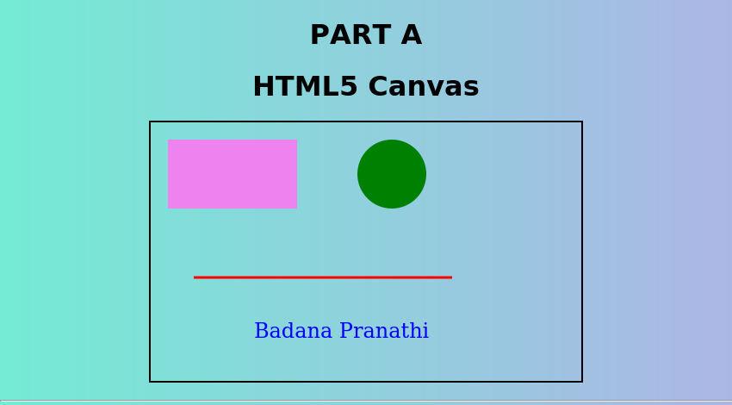
Part B - Styled Webpage (Header, Navigation, Cards, Footer)
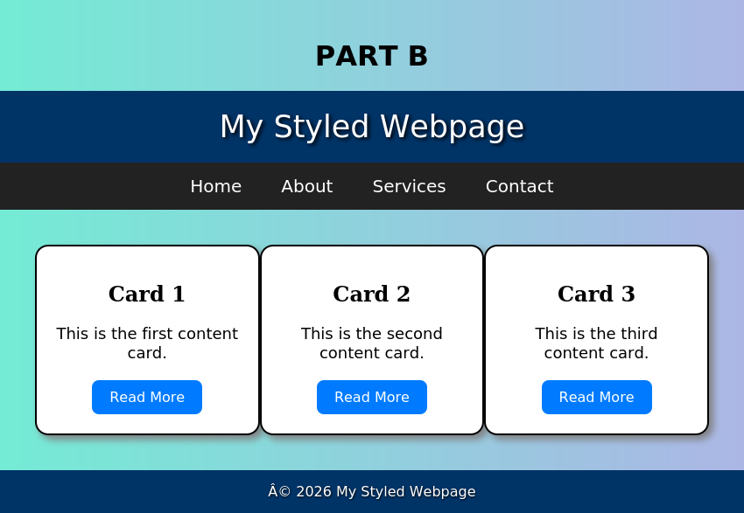

10. RESULT
Thus, shapes and text were successfully drawn on an HTML5 canvas using JavaScript, and a visually styled webpage using internal CSS with gradients, Flexbox layout, and hover effects was successfully designed, implemented, and verified.

